

Transaction Tracking Service (TTS) Plug-In Starter Kit
Installation and Administration Guide

EN-Node
.Net Version

Version: 1.0

December 23, 2011



1368 How Lane
North Brunswick, New Jersey 08902
www.enfotech.com

Revision History
Version | Date | Created By | Reviewed By | Description
1.0 | 12/21/2011 | Charlie Tsai |  | Release for public use

Tables of Contents

1 Document Purpose 4
2 Plug-In Overview 4
3 Installing the Plug-In 4
3.1 Prerequisites 4
3.2 Installation Package Contents 4
3.3 Installation Instructions 4
4 Testing the Plug-in 7
4.1 Test GetTransactionList Query 7
4.2 Test GetTransactionDetail Query 8

Document Purpose
The purpose of this document is to provide guidance on the setup, use, and maintenance of the EN-Node Transaction Tracking Service (TTS) Plug-ins.
Transaction Tracking Services allow administrators to search and analyze user activities and other related information associated with a dataflow during a specific period of time.

Plug-In Overview

Two different TTS plug-ins are available under the TTS data flow:
- GetTransactionList: A Query service that provides a listing of transactions meeting specific search criteria
- GetTransactionDetail: This service returns all available transaction details associated with a given Transaction ID.

Installing the Plug-In

Prerequisites
- EN-Node has been installed
- MS SQL server has been installed

Installation Package Contents
This section identifies the files that are provided as part of the TTS Plug-In Installation Package. The TTS Plug-In Installation Package includes the following:

- GetTransactionList_DataWizardConfig.xml: Node Plug-In Configuration file that defines the step-by-step logic for the GetTransactionList Query
- GetTransactionDetail_DataWizardConfig.xml: Node Plug-In Configuration file that defines the step-by-step logic for the GetTransactionDetail Query
- USP_GENERATE_TRANSACT_SVC_XML.sql: Stored procedure script which generates an XML file for GetTransactionList Query.
- USP_GENERATE_TRANSACT_DTL_XML.sql: Stored procedure script which generates an XML file for GetTransactionDetail Query.

Installation Instructions
To create and configure the TTS Node Plug-Ins please follow these steps:

- Run the following scripts in the existing Node database:
  - USP_GENERATE_TRANSACT_SVC_XML.sql
  - USP_GENERATE_TRANSACT_DTL_XML.sql

- Update the two …Wizard.xml files with your state or tribe specific database connection information:
  - Correct the connection string to point to your EN-Node data source:
i.e. <parameter name="dataSource" value="MSSQL:server=xxxxx; database=xxxxx;UID=xxxxx; password=xxxxx;" type="System.String" />
- Create the GetTransactionList Operation:
  - Log into the Node Administration Console. Under the Node Domains webpart, and click the “Go to Operations” link for the Node Domain
  - Click the “Create Operation by XML” button
  - Click Browse and select the GetTransactionList_DataWizardConfig.xml from the package.
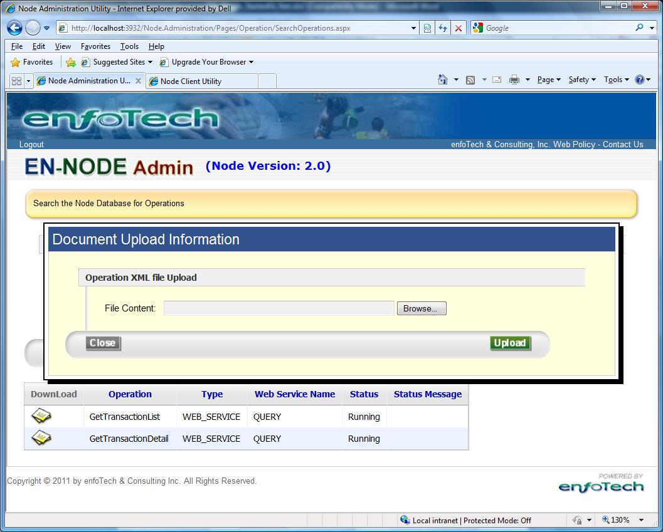
  - Click Upload to Create the GetTransactionList Operation.
  - The following information should be displayed in the operation information section:
    - Operation Name: GetTransactionList
    - Operation Type: Web Service
    - Web Service: Query
  - The follow parameters should be listed:
    - transID
    - DataFlow1
    - Status
    - Type
    - UserId
    - Recipients
    - Organization
    - toDate
    - fromDate

- Create GetTransactionDetail Operation:
  - Log into the Node Administration Console. Under the Node Domains webpart, click the “Go to Operations” link for the Node Domain
  - Click “Create Operation by XML” button
  - Browse GetTransactionDetail_DataWizardConfig.xml from the package.
  - Click Upload to Create GetTransactionDetail Operation.
  - The following information should be shown in the operation information section:
    - Operation Name: GetTransactionDetail
    - Operation Type: Web Service
    - Web Service: Query
  - The follow parameters should be listed:
    - transID

Testing the Plug-in

Test GetTransactionList Query

Step 1: Authenticate to your node
First authenticate to your node using the Node Client tool:
- Node Address: Provide your Node endpoint
- User Name: Enter your NAAS username
- Password: Enter your NAAS password
- Then click the Authenticate button
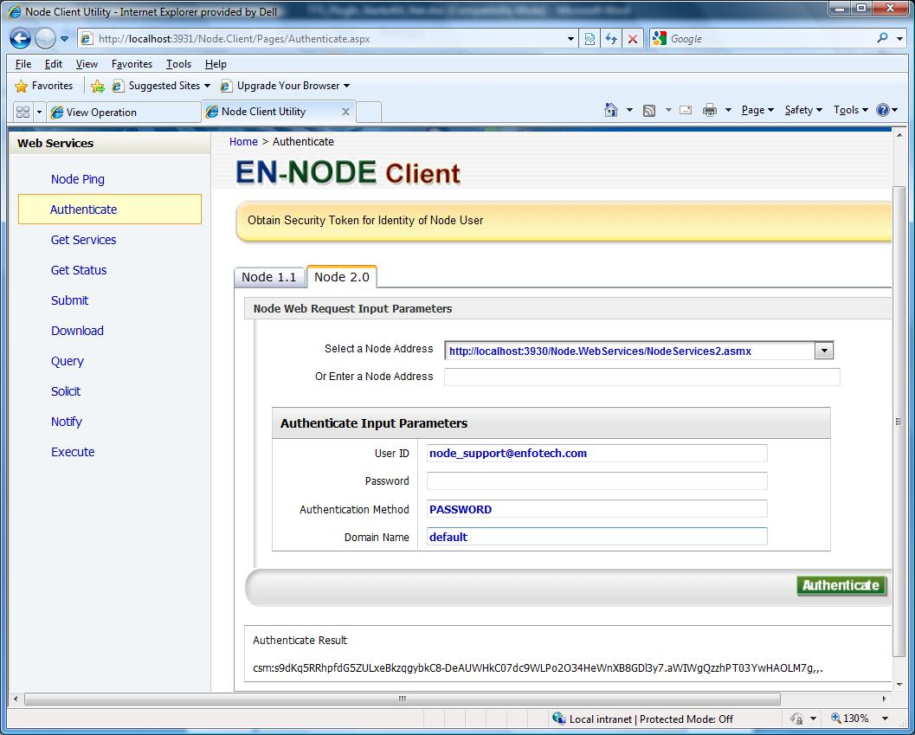

The Result should show a security token similar to the one above.

Step 2: Call FRS GetTransactionList Query
Click on the Query link on the left menu to query data from your Node. Fill in the following information:
- Security Token: should be automatically populated from the step above
- Request Name: GetTransactionList
- Parameters:
  - toDate: in format YYYY-MM-DD (required Field)
  - fromDate: in format YYYY-MM-DD (Required Field)

You should receive the following XML results as depicted below:
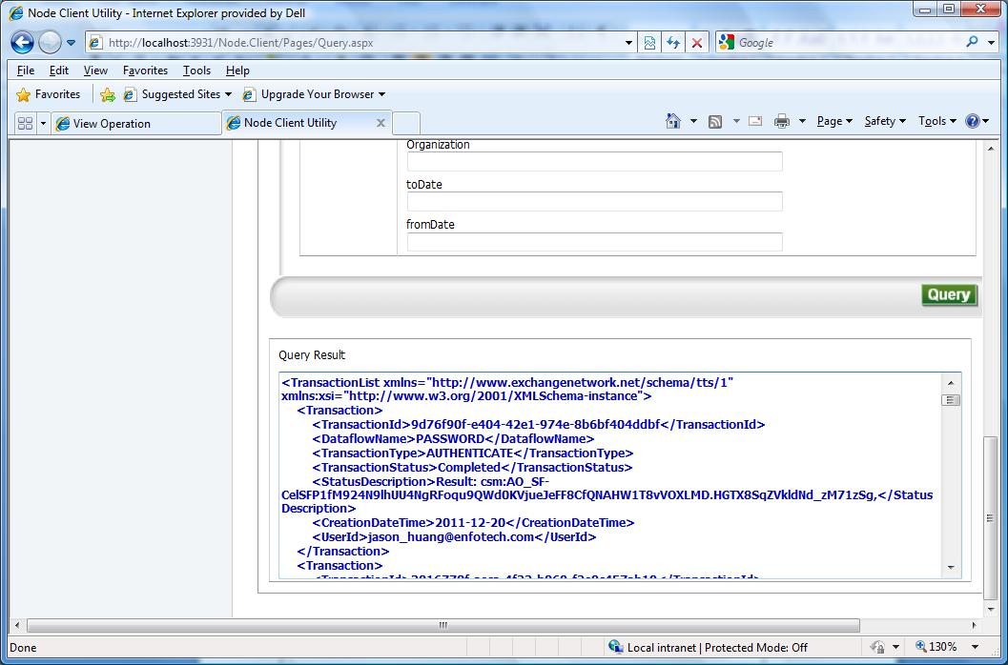

Test GetTransactionDetail Query

Step 1: Authenticate to your node
First authenticate to your node using the Node Client tool:
- Node Address: Provide your Node endpoint
- User Name: Enter your NAAS username
- Password: Enter your NAAS password
- Then click the Authenticate button

Step 2: Call the FRS GetTransactionDetail Query
Click on the Query link on the left menu to Query data from your Node. Fill in the following information:
- Security Token: should be automatically populated from the step above
- Request Name: GetTransactionDetail
- Parameters:
  - transID: Get any transaction id from result of Section 4.1

You should receive the following XML results as depicted below:
